AE_5335 Homework 6

MATT PAHAYO

AE_5335 -> Dr. Riggins

2021

**Homework 6 AE 5335 Assigned: 3/19/2021**

**Due: 3/31/2021**

Consider a conventional nuclear thermal rocket as shown in the sketch below:

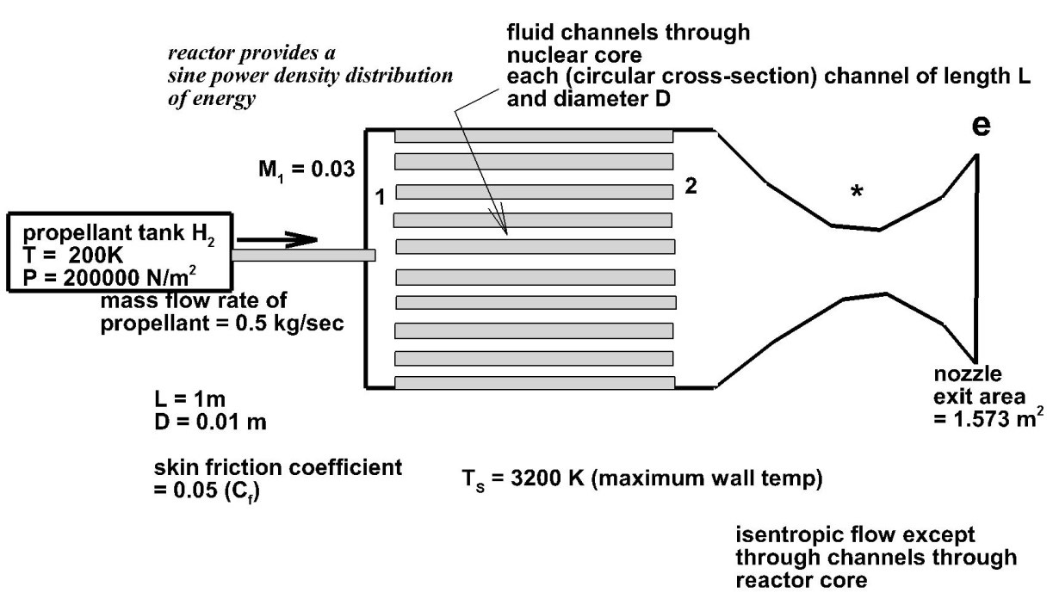

Let the skin friction coefficient = 0.05, L (length of tubes through core) =1 m, D (diameter of each tube) =

0.01 m.

Maximum temperature of wall in tubes = 3200K

Mach number at entrance of each tube (station 1) = 0.03

Total temperature and total pressure of H2 in propellant tank = 200K and 200000 N/m2

Mass flow rate of propellant is 0.5 kg/sec

Area of nozzle exit = 1.573 m2

Assume an axial sine power density distribution for the nuclear reactor in this nuclear rocket. Use ratio of specific heats γ= 1.4 and R (gas constant) = 4125 J/kgK for the hydrogen propellant.

Calculate and plot both the wall temperature and the total temperature of the propellant from tube entrance (station 1) to tube exit (station 2).

Find the axial location of the maximum wall temperature.

Find the total heat rate generated by the reactor for this rocket.

Find the thrust and the specific impulse of this rocket.

**Results**

Calculate and plot both the wall temperature and the total temperature of the propellant from tube entrance (station 1) to tube exit (station 2).



Find the axial location of the maximum wall temperature.

Find the total heat rate generated by the reactor for this rocket.

$$\dot{Q}=21146750.47962 J/s$$

Find the thrust and the specific impulse of this rocket.

$$thrust=4.593 kN$$

$$ISP=937.461 sec$$

**Scratch work and code**

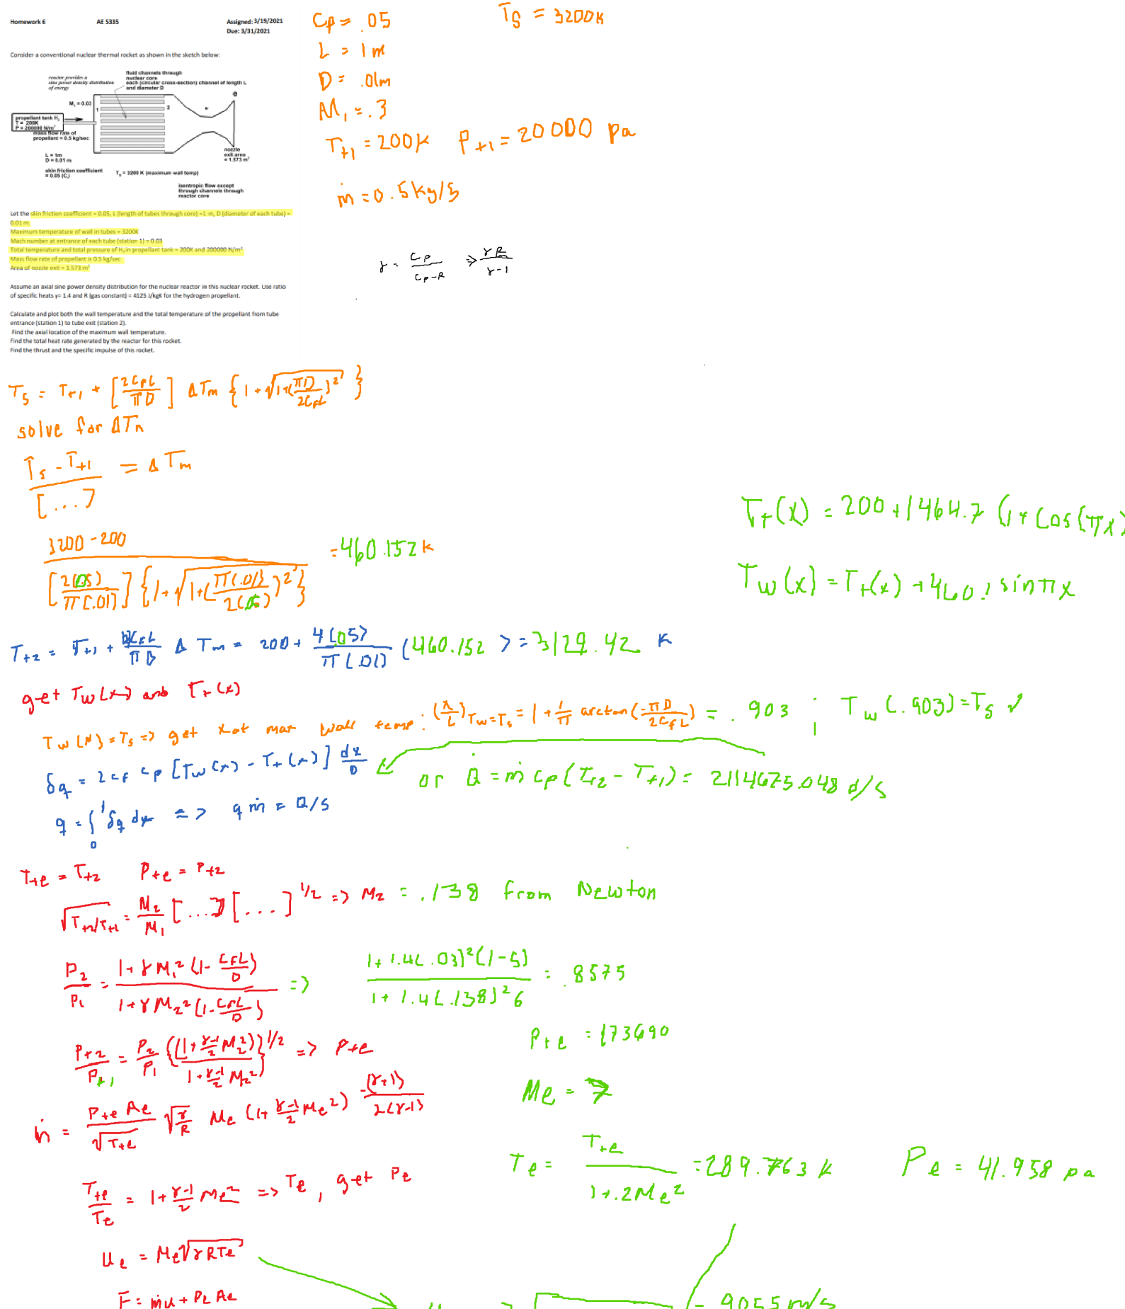Saturday, April 3, 2021 4:04 AM

hw Page 1

classdef rootFind

%rootFind is a class of functions that find the root of a function /

%data set

%------------------------------------------------------------------------%

methods (Static)

function x = Bisect(f,a,b,tol)

%Bisect uses the bisection algoritm using the interval

iter = 0;

while (b-a)/2 >= tol

c = (a+b)/2;

if f(c) > 0

b = c;

end

if f(c) < 0

a = c;

end

iter = iter + 1;

end

x = (a+b)/2

end

%------------------------------------------------------------------------%

function x = newRap(f,x0)

%newRap is a function that utilizes the Newton-Raphson

%algorithm to find the roots of the function

%x0 is the initial guess

fp = diff(f);

x=x0;

nmax=25;

eps=1;

n=0;

while eps>=1e-5&&n<=nmax

y=x-double(f(x))/double(fp(x));

eps=abs(y-x);

x=y;

n=n+1;

end

end

%------------------------------------------------------------------------%

end

end

% matthew Pahayo

% main.m

clc

clear all

close all

format longg

syms x M2 Me

cf = .05;

L = 1;

D = .01;

M1 = .03;

Tt1 = 200;

Pt1 = 200000;

mdot = .5;

Ts = 3200;

gam = 1.4;

R = 4125;

cp = gam*R/(gam-1);

Ae = 1.573;

delTm = (Ts-Tt1)/(2*cf*L/pi/D)/(1+sqrt((1+((pi*D)/(2*cf*L))^2)))

Tt2 = Tt1+4*cf*L/pi/.01*delTm

Tt = symfun(2*cf/D*delTm*L/pi*(1-cos(pi*x/L))+Tt1,x)

Tw = Tt + delTm*sin(pi*x/L)

xbyL = 1 + 1/pi*atan(-pi*D/2/cf/L)

Qdot = int(2*cf*cp*(Tw-Tt)/D,0,1)*mdot

f = symfun(-sqrt(Tt2/Tt1)+(M2/M1)*((1+gam*M1^2*(1-cf*L/D))/(1+gam*M2^2*(1+cf*L/D)))*...

((1+(gam-1)/2*M2^2)/(1+(gam-1)/2*M1^2))^(1/2),M2)

M2 = rootFind.newRap(f,0)

Pr = ((1+gam*M1^2*(1-cf*L/D))/(1+gam*M2^2*(1+cf*L/D)))

Pte = Pr*((1+(gam-1)/2*M2^2)/(1+(gam-1)/2*M1^2))^(gam/(gam-1))*Pt1

g = symfun(Pte*Ae/sqrt(Tt2)*sqrt(gam/R)*Me*(1+(gam-1)/2*Me^2)^(-(gam+1)/2/(gam-1))-mdot,Me)

Me = rootFind.newRap(g,3)

Te = Tt2/(1+(gam-1)/2*Me^2)

Pe = Pte/((1+(gam-1)/2*Me^2))^(gam/(gam-1))

ue = Me*sqrt(gam*R*Te)

thrust = mdot*ue + Pe*Ae

ISP = thrust/mdot/9.8

for i = 1:100

Twall(i) = double(Tw(i/100));

Ttotal(i) = double(Tt(i/100));

Tes(i) = Ts;

end

i = 1:100;

hold on

plot(i,Twall)

plot(i,Ttotal)

plot(i,Tes,'--')

legend('Tw','Tt','Max wall temperature','Location','southeast')

ylabel('Temperature [K]')

xlabel('length across channel [cm]')

title('Temperature across channels')

grid on

hold off